Very Simple way to set a **ONCLICK LISTNER** on a button in order to change the image in the **ImageView.**

1. Create a button and imageView section in your file. And give the **unique id** to **imageView** and **Button** Like this:

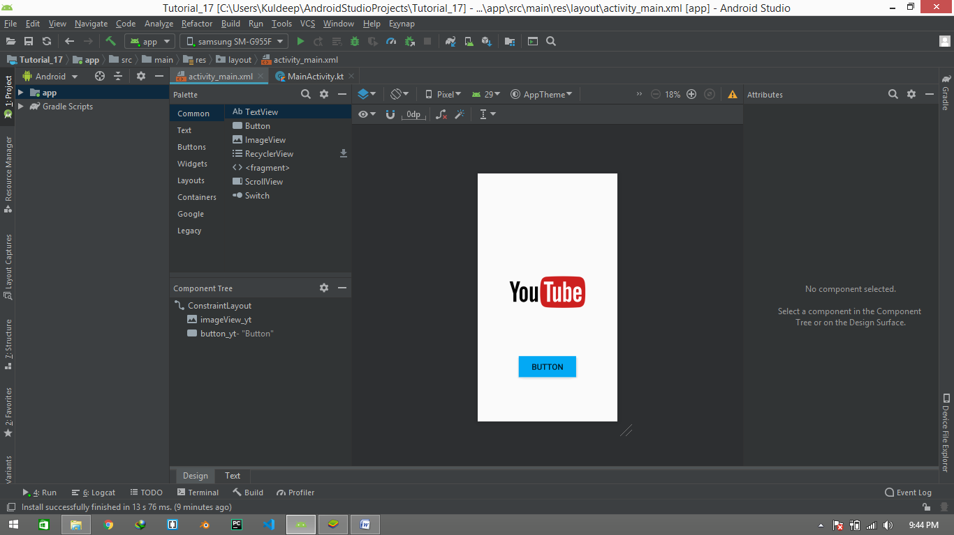

1. Now Go to **MainActivity.kt** File. Here you will see your **MainActivity Class** and **default oncreate function** to create the panel n android. We do all our stuffs in this function for . **WRITE NOW!**

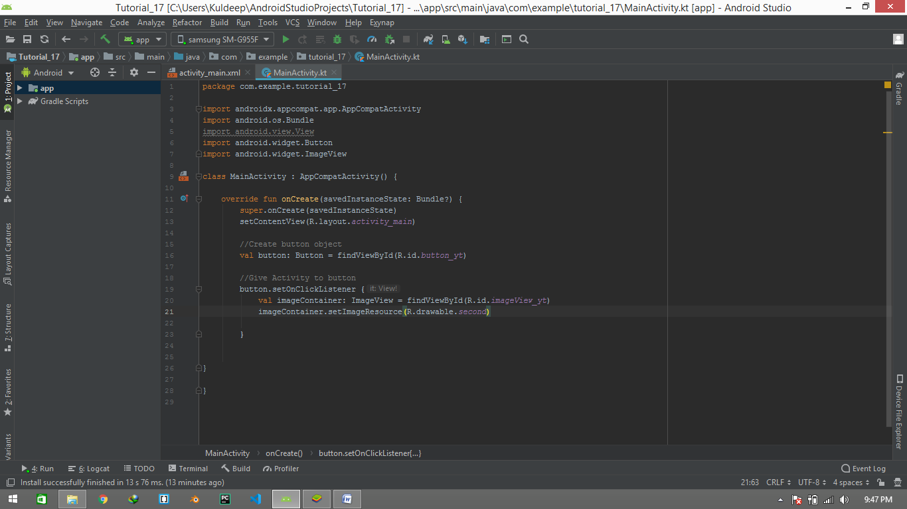

1. Now first of all we have to create an object for our button . for that purpose we use Following code of Line:-

//Creating button object  
val button: Button = findViewById(R.id.*button_yt*)

Here val is a keyword creating a object **button** for Component **Button** and

in this object we assign the id of our button which we created in Design section by using **“findViewById(R.id.button_yt)”** here

**R –** stands for Read

**Id –** Detecting the id of the Button component from your .xml file.

**And** button_yt is the unique id of the button .

1. Now we Created the button Object . So the next step is to use the object and call the “**setOnClickListener”**  . follow below step:-

//Give Activity to button, button is your object and “setOnClickListener” is //your function   
button.setOnClickListener **{  
 // declare your activity**  
**}**

1. Now we create object for Imageview by using same method , and use its object to change the image of the ImageView when we click the button . Like that:-

//Give Activity to button  
button.setOnClickListener **{** val imageContainer: ImageView = findViewById(R.id.*imageView_yt*)  
 imageContainer.setImageResource(R.drawable.*second*)

**}**

Here **imageContainer** is an object and **setImageResource** and **drawable** is the name of the folder and **second** is the name of **the image** that we wanna to replace with the original image.

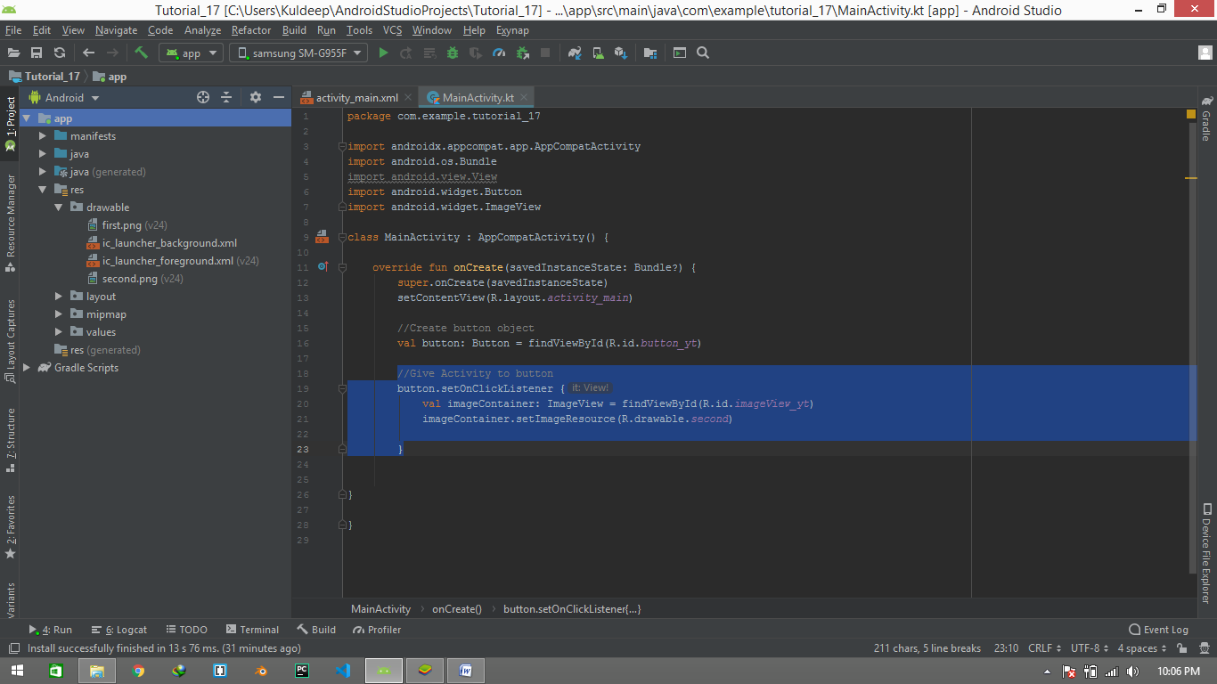

1. Now Run the Program.

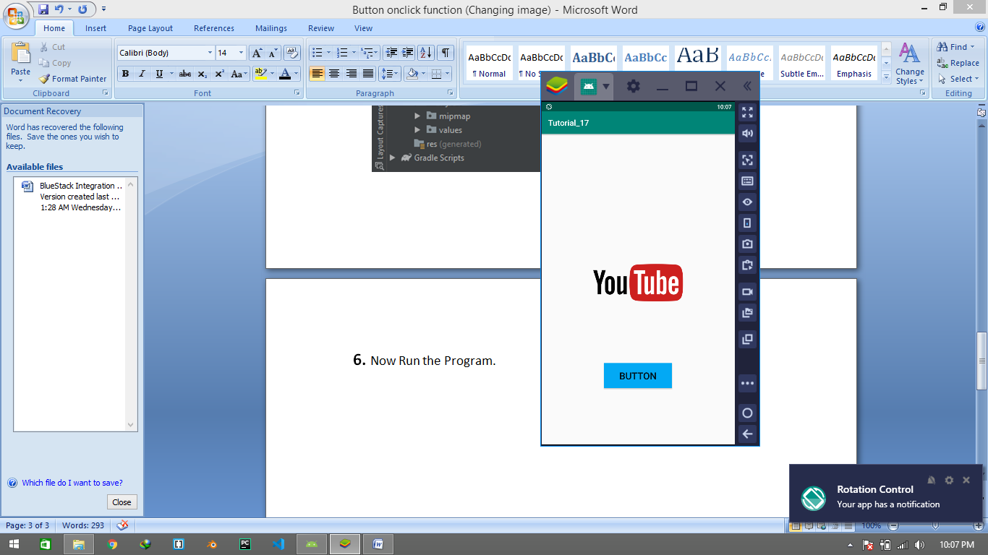 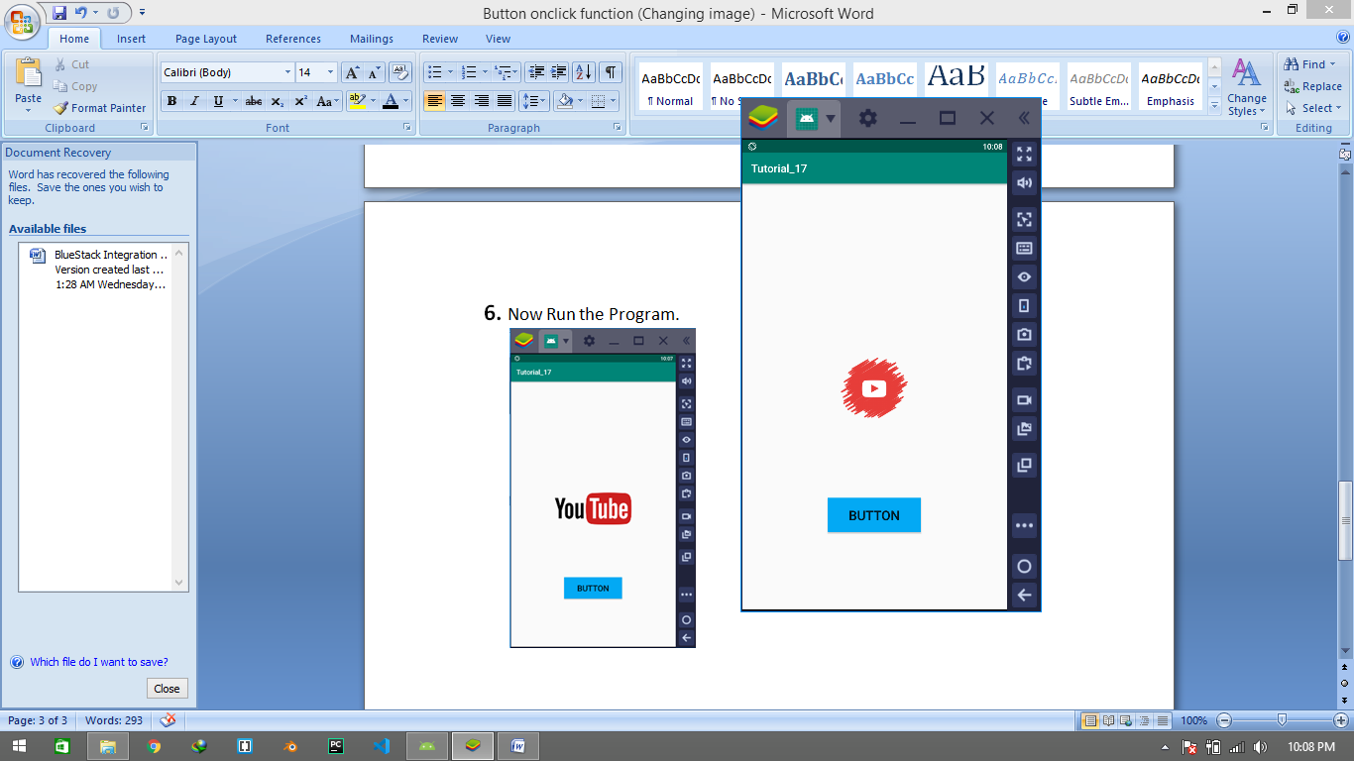

Before click(img 1) after click(img 2)